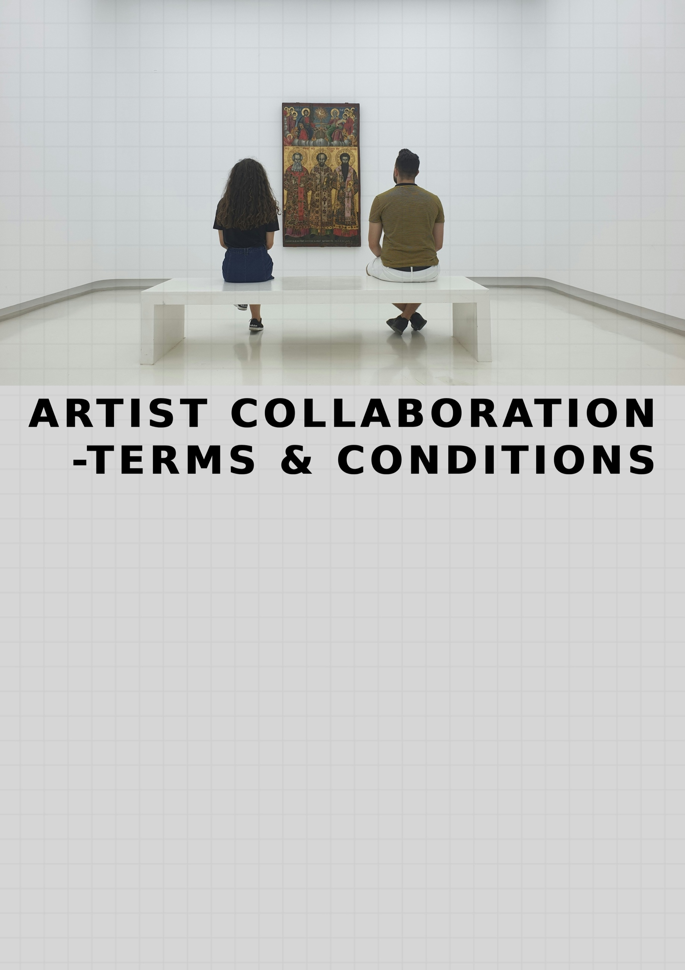
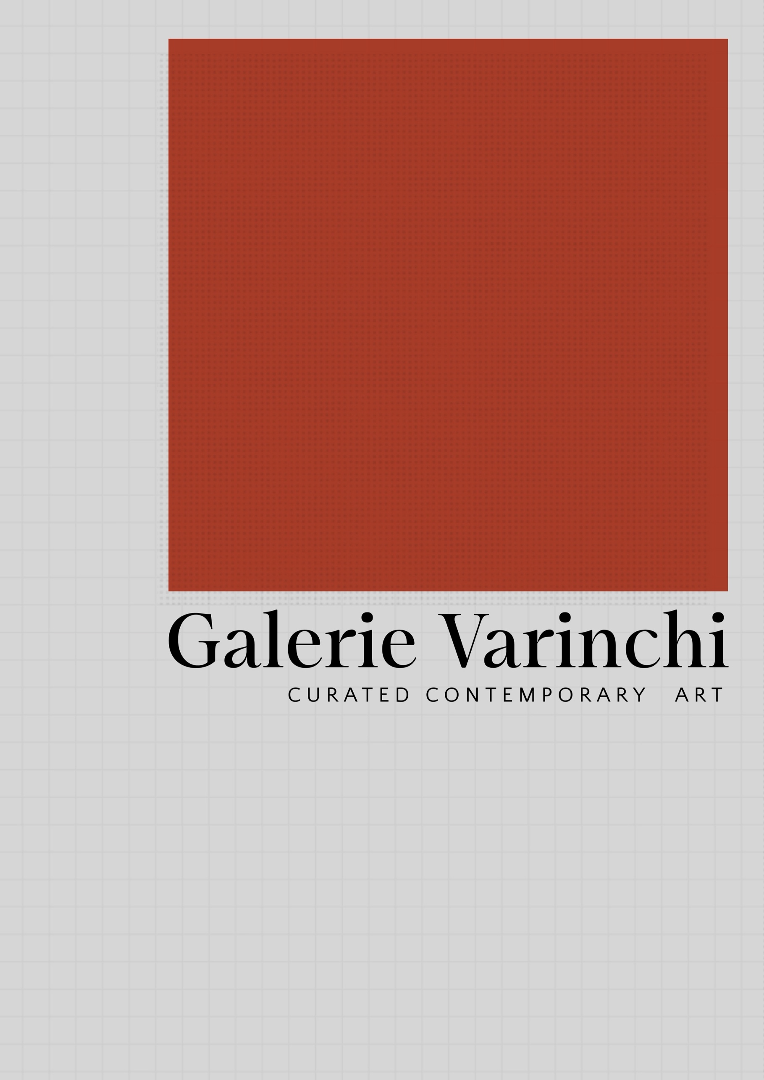
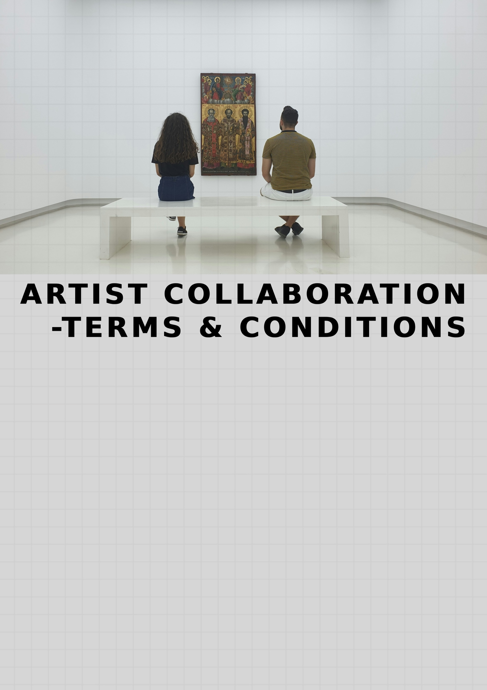



Galerie Varinchi

Artist Collaboration Terms & Conditions
These Terms and Conditions govern the collaboration between Galerie Varinchi ("the Platform") and the Artist whose artworks are licensed for reproduction and sale through the Galerie Varinchi platform.
By entering into collaboration with Galerie Varinchi, the Artist agrees to the following terms.

1. Definitions
Artist
The creator and copyright holder of the artwork licensed to Galerie Varinchi.
Artwork
Any digital artwork, illustration, painting, photograph, or visual work submitted by the Artist for reproduction and sale.
Artist Base Value (X)
The original price assigned to the artwork by the Artist.
Retail Price (Y)
The final selling price of the artwork to customers, excluding Goods and Services Tax (GST).
Net Revenue
The retail selling price excluding GST.

2. Nature of Collaboration
The Artist grants Galerie Varinchi a non-exclusive license to reproduce selected artworks as curated prints and sell them through the Galerie Varinchi platform.
This collaboration allows the Artist to monetize their artwork while Galerie Varinchi manages production, logistics, and sales operations.

3. Ownership & Copyright
All artworks remain the intellectual property of the Artist.
The Artist retains:

- Full copyright ownership

- Moral rights associated with the artwork
- The right to sell original artworks
- The right to license the artwork to other parties
Galerie Varinchi receives only the limited rights necessary to reproduce and sell prints of the artwork under the agreed licensing terms.
Exclusions : Some prints are made under special request, exclusively for Galerie Varinchi will be sold as limited edition prints. It will be exclusive, sold limited in numbers, and should not be available through any other channels to maintain the uniqueness.

4. Licensing Rights
The Artist grants Galerie Varinchi the right to:
- Reproduce the artwork as printed editions
- Display the artwork on the Galerie Varinchi website and marketing materials
- Sell the printed artwork to customers through official Galerie Varinchi sales channels
This license is non-exclusive, meaning the Artist may continue to sell or license the artwork elsewhere.
However, some selected limited edition prints released through the platform may be exclusive to Galerie Varinchi and will not be made available for sale through other channels, ensuring their uniqueness and collectible value.

5. Usage Limitations
The licensing rights granted to Galerie Varinchi are subject to the following limitations:

5.1 Print Reproduction Only
The artwork may be reproduced only for the purpose of producing and selling art prints through the Galerie Varinchi platform.
The artwork will not be used for merchandise such as:
- Clothing
- Home décor products unrelated to prints
- Commercial product packaging
without explicit written permission from the Artist.

5.2 No Unauthorized Modification
Galerie Varinchi will not alter the artwork in a manner that changes its artistic integrity.

Permitted technical adjustments include:
- Resizing for print formats
- Color correction for print accuracy
- Cropping required for standard print ratios

5.3 No Third-Party Licensing
Galerie Varinchi will not sublicense, distribute, or license the artwork to third-party platforms or marketplaces without the Artist’s written consent.

5.4 Marketing Use
Galerie Varinchi may use the artwork images for:
- Website display
- Social media promotion
- Marketing campaigns related to the platform
These uses are strictly for promoting the artwork and the platform.

6. Royalty Structure
Digital Artworks (Art print reproduction)
Royalty payments are calculated based on Net Revenue (Retail Price excluding GST).

Artist Base Value (X) : Decided by Artist for respective Artworks while submission. Final price of the piece to be listed on the platform will be finalised by Galerie Varinchi by adding framing cost, packaging cost, shipping cost, margin etc.

Phase 1 – Initial Royalty Recovery
For each sale, the Artist receives:
33% of Net Revenue (Y, excluding GST)
This payment continues until the total royalty paid equals the Artist Base Value (X).
This ensures that the Artist receives the full value assigned to the artwork.


Phase 2 – Ongoing Royalty
Once cumulative royalties reach the Artist Base Value (X):
The Artist will receive:
7% of Net Revenue (excluding GST)
This royalty continues for as long as the artwork remains available for sale on the platform.
Handmade Art works (single piece):
Artist Base Value (X), decided by the Artist will be paid to the Artist. Final price of the piece to be listed on the platform will be finalised by Galerie Varinchi by adding framing cost, packaging cost, shipping cost, margin etc. Product photoshoot for the same has to be done before listing. Product has to be handed over to Galerie Varinchi for Photoshoot.
Royalty payout will be done monthly. It will take upto 18 days for the royalty to be credited to the Artist’s wallet after each sale. This time period is to confirm that there is no return for the product. In case of product return, refund to the customer is normally not an option, but in the worst case scenario if it happens due to any unforeseen escalation, the royalty for that particular sale will be cancelled.

7. Production & Fulfilment
Galerie Varinchi manages the entire production and sales process including:
- Fine art printing
- Framing
- Packaging
- Order processing
- Shipping and delivery
- Customer support
Artists are not required to manage any operational aspects of order fulfilment.

8. Sales Reporting & Payments
Galerie Varinchi will maintain records of all artwork sales.
Artists will receive:
- Periodic royalty statements
- Royalty payments according to the agreed payment cycle
Payments will correspond to the royalty amounts generated from sales.


9. Artist Responsibilities
The Artist agrees to:
- Provide high-resolution artwork files suitable for printing
- Confirm that they hold full rights to the artwork
- Ensure the artwork does not infringe on third-party copyrights
- Provide accurate information regarding the artwork
The Artist is responsible for any legal claims arising from ownership disputes or copyright violations.

10. Artwork Quality & File Requirements
Artists must provide files suitable for professional printing.
Typical requirements may include:
- High-resolution digital files
- Correct color profiles
- Adequate dimensions for print sizes offered
Galerie Varinchi may request revised files if the submitted artwork does not meet production standards.

11. Artist Promotion
Promotion of Artists will be done by Galerie Varinchi through the platform website and social media channels. Artist grants permission for using their photographs, Bio, Videos/Photos of the process of making art for promotional purpose.

12. Artist Exit Policy
An Artist may choose to terminate their collaboration with Galerie Varinchi by providing written notice.
Upon termination:
- The Artist's profile may be removed from the platform.
- No new listings of the Artist's artworks will be created.
Existing customer orders that were placed prior to termination will still be fulfilled.

13. Artwork Withdrawal Policy
Artists may request removal of specific artworks from the platform.
Upon withdrawal:
- The artwork will no longer be available for new sales.
- Existing customer orders placed before the withdrawal request will still be fulfilled.
- Previously sold artworks remain valid collectible prints.

14. Platform Rights to Remove Artwork
Galerie Varinchi reserves the right to remove artwork from the platform if:
- The artwork violates legal regulations
- Copyright disputes arise
- The artwork does not meet platform standards
- The collaboration agreement is terminated

15. Limitation of Liability
Galerie Varinchi will take reasonable care in handling artwork files and print production.
However, the platform will not be liable for:
- Market performance of artworks
- Sales volume or demand
- External disruptions affecting production or shipping

16. Amendments to Terms
Galerie Varinchi may update these Terms and Conditions when necessary.
Artists will be notified of significant changes affecting their collaboration.

17. Governing Law
These Terms and Conditions shall be governed by the laws of India.
Any disputes arising from this collaboration shall fall under the jurisdiction of the appropriate courts in India.

